Experiment 3:
Survey Report on Emerging Trends

1.Aim
To study the emerging trends in Low-Code Application Development, compare traditional application development with low-code development, analyze its benefits and challenges, and compare existing low-code application development platforms.
2. Traditional Application Development vs Emerging Trends in Low-Code Application Development
Feature | Traditional Development | Low-Code Development
Coding | Extensive coding required | Minimal coding required
Development time | Usually longer | Usually faster
Technical knowledge | High programming knowledge | Basic to moderate coding knowledge
UI development | Mostly coded manually | Visual drag-and-drop interface
Reusable components | Developed manually | Many pre-built components available
Prototyping | Takes more time | Rapid prototyping
Maintenance | Requires developer involvement | Easier for many applications
Customization | Highly customizable | Depends on platform
Deployment | Often requires more configuration | Many platforms provide simplified deployment
Target users | Mainly professional developers | Developers and citizen developers
Cost | Can require more development resources | Can reduce development effort
Scalability | Highly flexible | Depends on platform architecture

3. Benefits and Challenges in Low-Code
Benefits
1. Faster Development
Applications can be developed faster because many components are already available.
2. Less Coding
Developers do not need to manually write every part of the application.
3. Easy Prototyping
Ideas can quickly be converted into working prototypes.
4. Reduced Development Effort
Pre-built components and templates reduce repetitive programming work.
5. Easy UI Design
Drag-and-drop interfaces make user interface development simpler.
Challenges
1. Limited Customization
Some complex requirements may require traditional programming.
2. Platform Dependency
Applications may become dependent on a particular low-code platform.
3. Security
Applications still need proper security configuration and monitoring.
4. Scalability
Some platforms may have limitations when applications become very large or complex.
5. Vendor Lock-In
Moving an application from one platform to another may be difficult.

4. Comparison of Existing Low-Code Platforms
Feature | Microsoft Power Apps | OutSystems | Mendix | Zoho Creator
Platform type | Low-code | Low-code | Low-code | Low-code
Main use | Business applications | Enterprise applications | Enterprise applications | Business applications
Visual development | Yes | Yes | Yes | Yes
Workflow automation | Yes | Yes | Yes | Yes
Database support | Yes | Yes | Yes | Yes
Cloud support | Yes | Yes | Yes | Yes
Mobile development | Supported | Supported | Supported | Supported
API integration | Supported | Supported | Supported | Supported
AI capabilities | Available | Available | Available | Available
Target users | Businesses and developers | Professional/enterprise teams | Businesses and developers | Small businesses and developers
Coding requirement | Low | Low | Low | Low

Form 1: Claimant Details
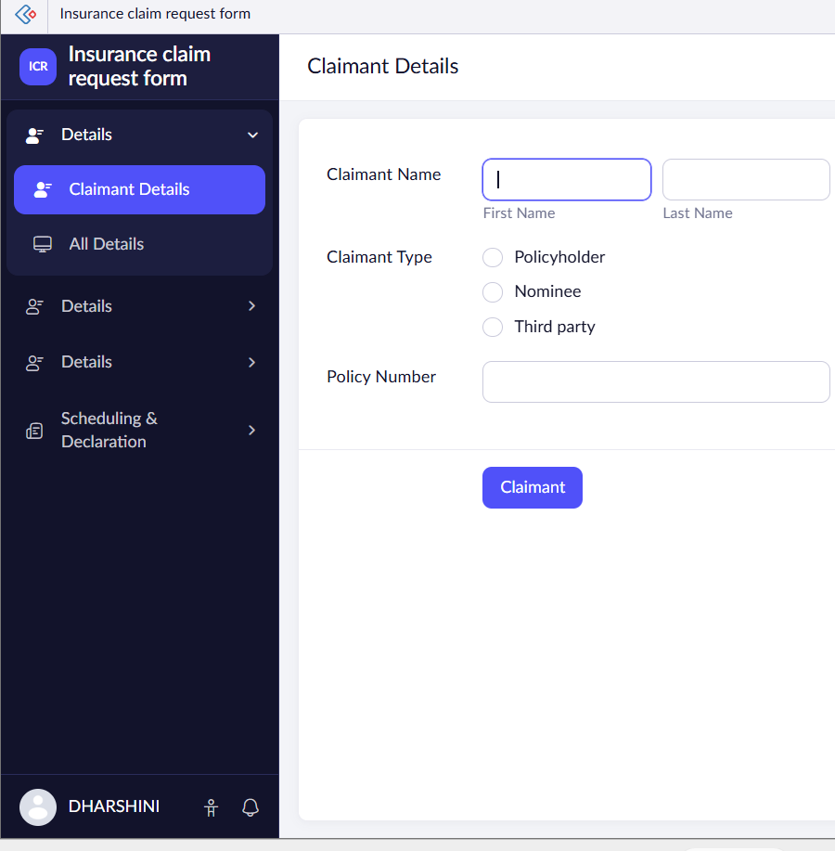
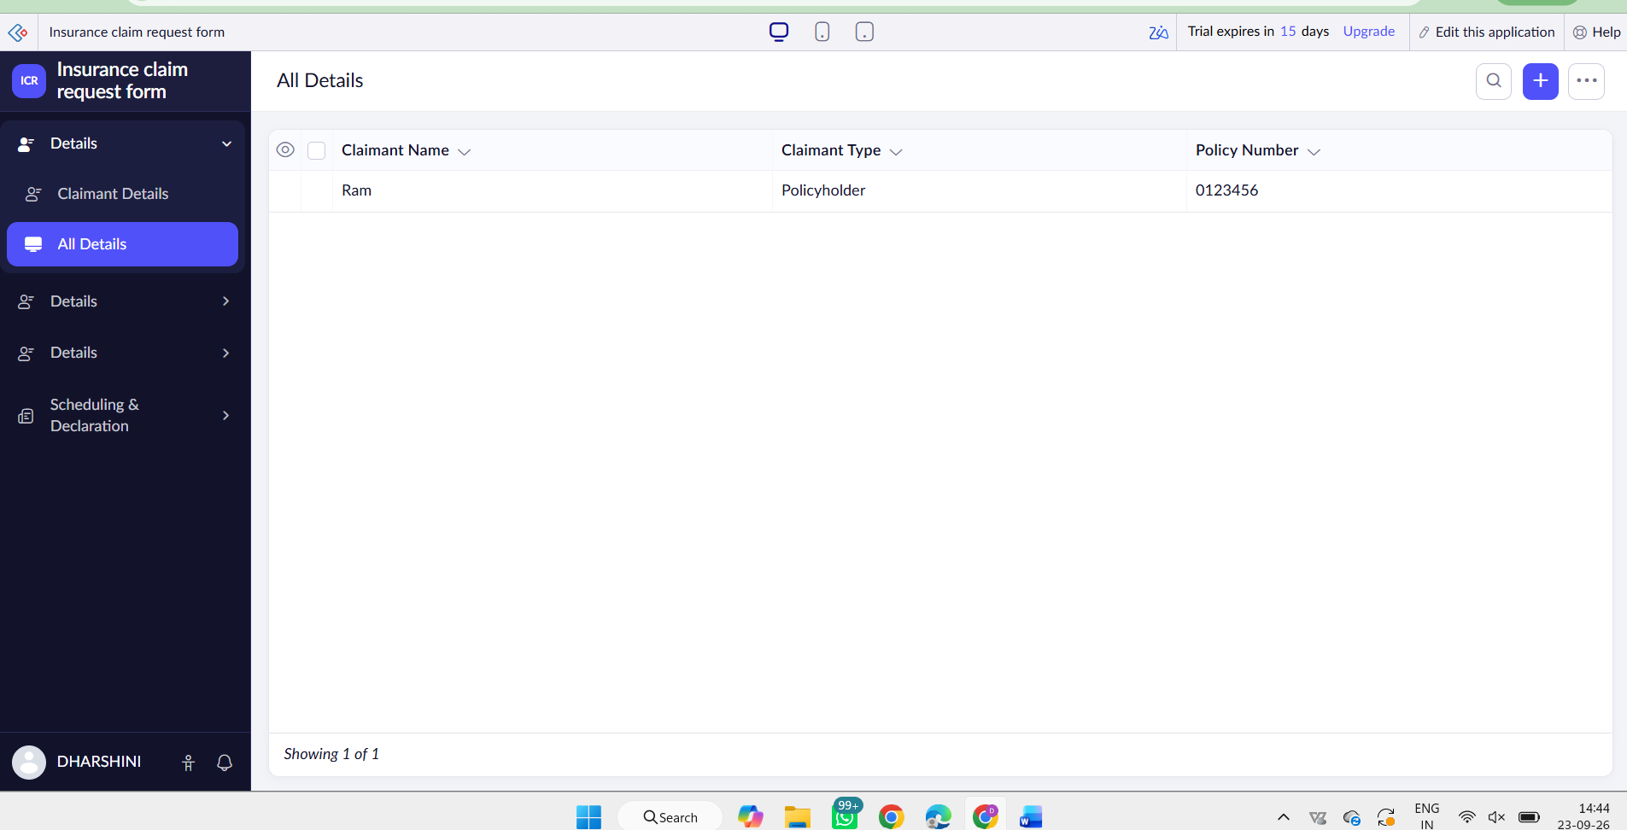
Form 2:
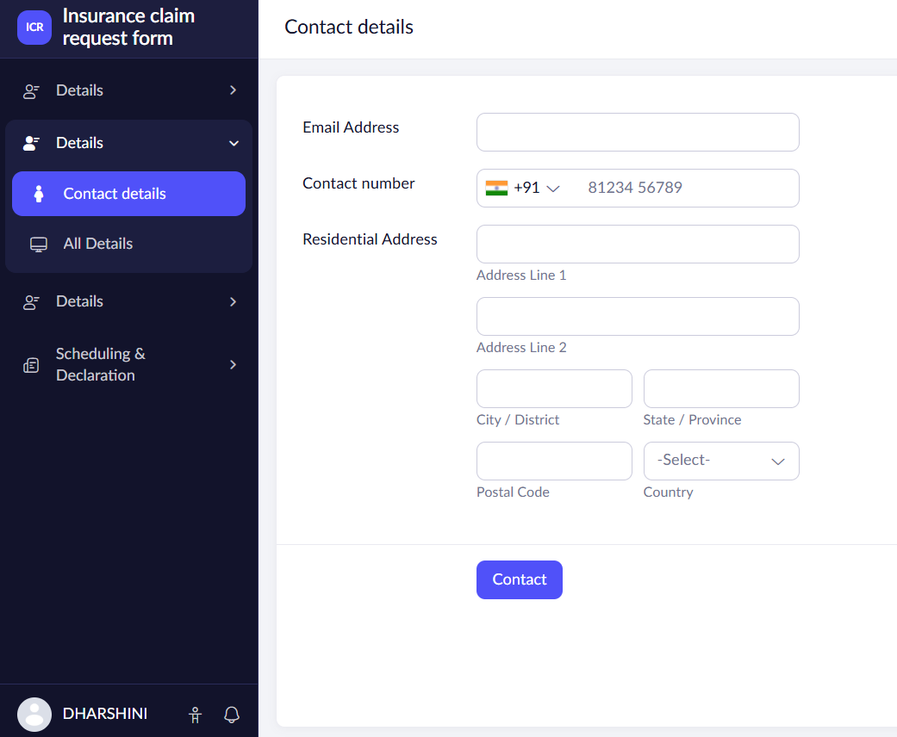
Form 3 Claim Details
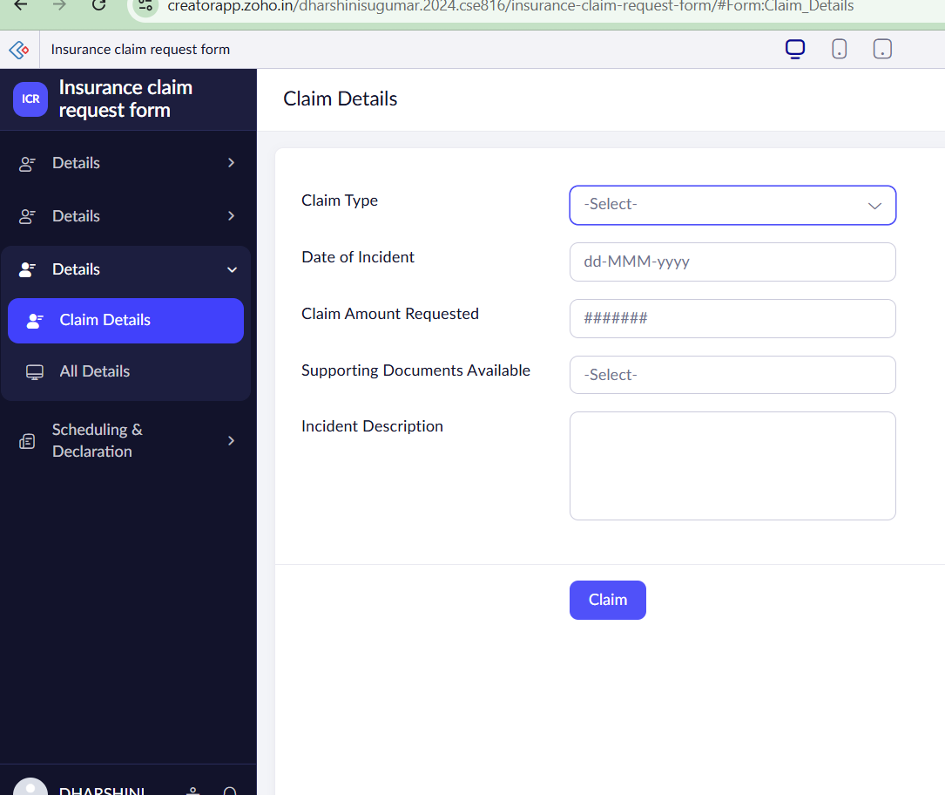
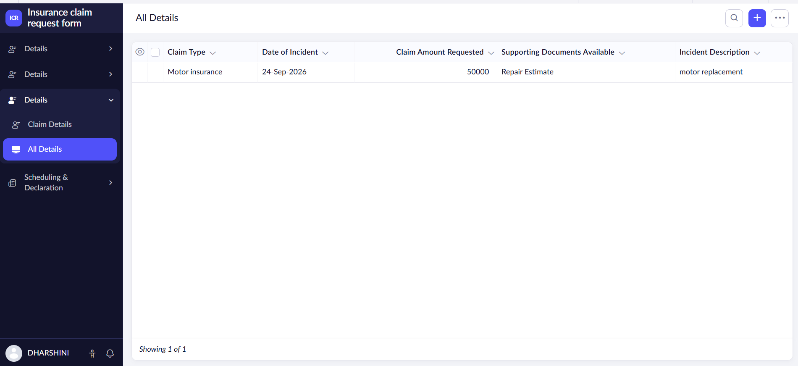

Form 4 Scheduling & Declaration
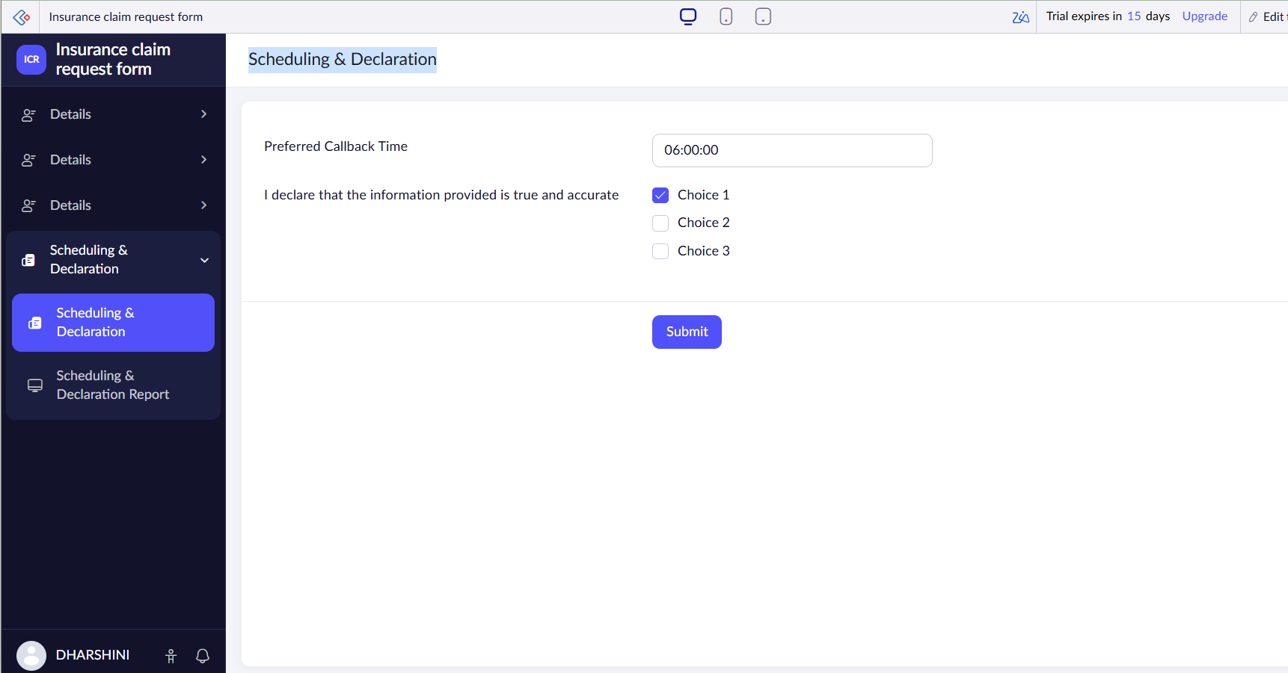
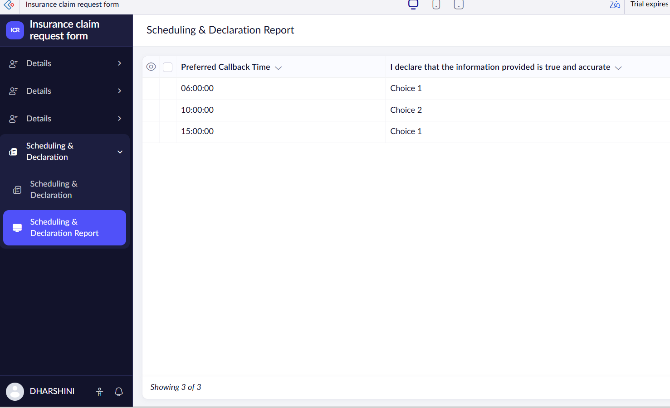
5. RESULT
The survey was conducted to study the emerging trends in low-code application development. Traditional development requires extensive programming, whereas low-code platforms provide visual development, reusable components, workflow automation and faster application development.
The study also identified important benefits such as reduced development time, rapid prototyping and easier application development, along with challenges such as platform dependency, security, customization and scalability.

